Wednesday 1st July 2020
Dear Parent/Carer,
Re: JUNIOR SWIMMING FOR YEAR 5 & 6

The primary swimming programme at Tarleton Academy is hopefully due to start on Thursday, 9th September 2020. Years 5 and 6 will swim in the Autumn Term, Years 3 & 4 the Spring Term and the Infants in the Summer Term, all being well. The children will need to leave school at 8.35am, swim between 9.00am and 9.45am, and return to school by around 10.15am. Please can you ensure your child arrives by 8.30am.

Girls must wear a ‘one piece’ swimming costume; boys preferably swimming trunks, although swimming shorts will be permitted providing they finish well above the knee (we have found that long shorts are a hindrance when swimming).

All children are required to wear a swimming hat, clearly labelled at the front with their name. The swimming instructor would prefer children did not wear goggles, however, if parents deem this to be necessary a separate consent form must be signed (these are available from our school office. If you have signed a form previously, another is not required).

Kit, including towel, is best kept in a suitable bag. Please do not send your child with toiletries (e.g. shower gel, shampoo, deodorant or talcum powder etc).

All kit should be clearly labelled with the child’s name.

Please complete the form overleaf and return it to school as soon as possible.

Yours sincerely,

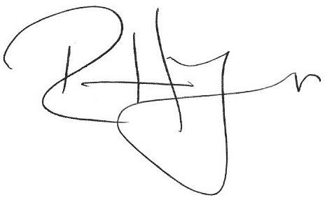

Mr R Higson

Re: Primary Swimming Programme Year 5 & 6

NAME OF CHILD : __________________________________

- Has your child any swimming experience? : Once a week or more / Once a month /
Couple of times a year / Never

- Does your child need to wear arm bands? : Yes / No

If so, how far can they swim with arm bands? : ______metres

- Please state how far your child can swim unaided : ______metres

I give consent for my child to take part in swimming lessons at Tarleton Academy each Thursday throughout the Autumn term 2020. I agree to provide a swimming hat and an appropriate costume.

Signature of Parent : ___________________________

Date : ___________________________

